Fort Smith Public Schools

PROFILE: K-2 Elementary Students
Number of Students: 2,483
Grade Levels: Kindergarten-2nd Grade
Lindamood-Bell Programs Implemented:
- Seeing Stars®
- Visualizing and Verbalizing®
Outcome Measures: IStation ISIP Universal Screener

BACKGROUND:
Fort Smith Public Schools in Fort Smith, AR, serves a large percentage of students who are at-risk of reading failure. During the 2017-2018 and 2018-2019 school years, Fort Smith Public Schools implemented Lindamood-Bell® instruction to address the specific needs of this student population. Teachers at Fort Smith Public Schools received professional development in the programs developed by Lindamood-Bell’s founders: Seeing Stars, to develop symbol imagery for reading, and Visualizing and Verbalizing, to develop concept imagery for comprehension. Students in grades K-2 received 15 minutes of daily instruction in a whole classroom Tier 1 setting as a supplement to core reading instruction. Student gains were measured with the IStation ISIP Universal Screener.

K-2 Overall Reading: IStation ISIP Universal Screener
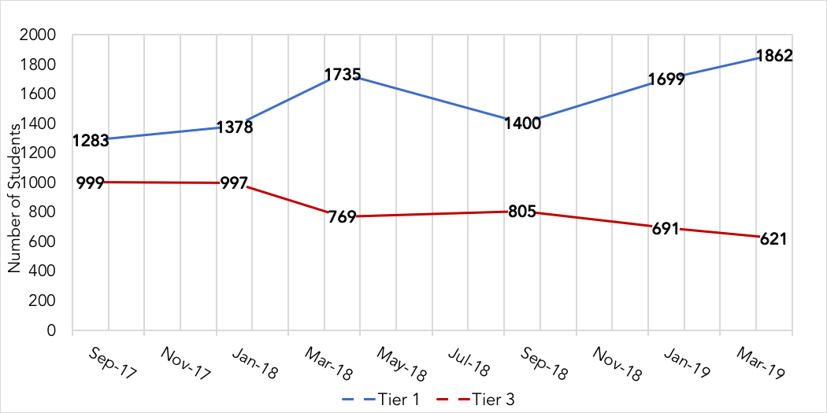
RESULTS:
Longitudinal data reflect an increase in the number of students scoring in the highest tier (Tier 1) and a decrease of students scoring in the lowest tier (Tier 3). This change dramatically alters the capacity of the district to provide intervention to its most at-risk readers. The results of this study illustrate that Lindamood-Bell instruction in the Seeing Stars and Visualizing and Verbalizing programs leads to improved reading, which is essential to achieving success with school curricula.

